NAME:HUSNA ALI

INTREES ID: TN/INO1/PY/011

TASK NUMBER 01:

print("Name: Husna")

print("Hobby:Reading")

print("Age:19")

print("I want to learn Python beacause its use in web development , data science")

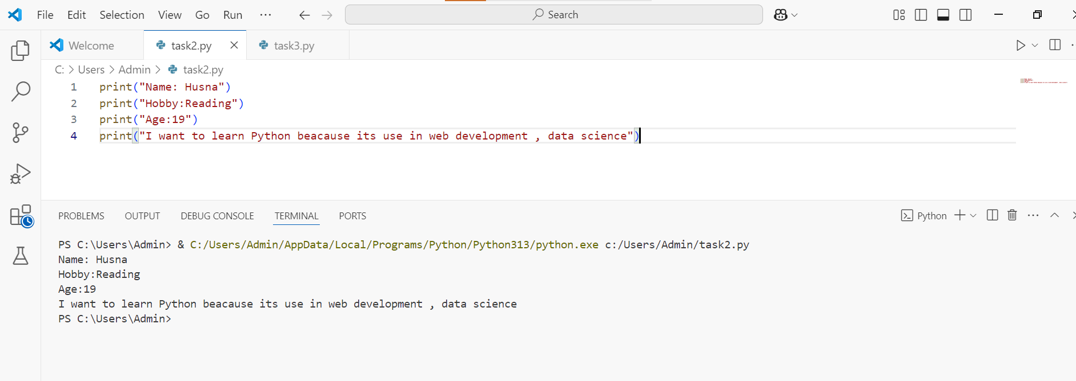

TASK NUMBER 02:

num1 = int(input("Enter first number"))

num2 = int(input("Enter 2nd number"))

result = num1 + num2

print("the sum is:",result)

